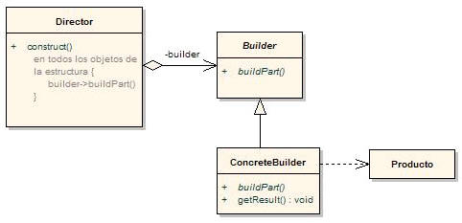DIAGRAMA UML PATRON BUILDER